Project Design Phase-I Solution Architecture

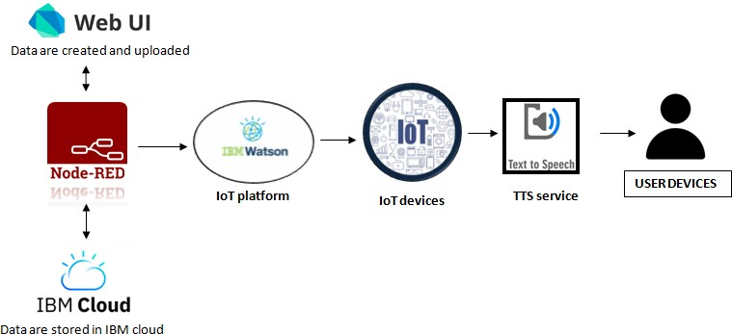

|  |  |
| --- | --- |
| **Date** | **18 October 2022** |
| **Team ID** | **PNT2022TMID31048** |
| **Project Name** | **Project-Personal Assistance for Seniors Who Are**  **Self-Reliant** |
| **Maximum Marks** | **4 Marks** |